# Tank Warz Tutorial

## Step 1. Create the project

* Launch GameMaker studio
* Select the “New” tab
* Select a project directory
* Give the project a name
* Click “Create”

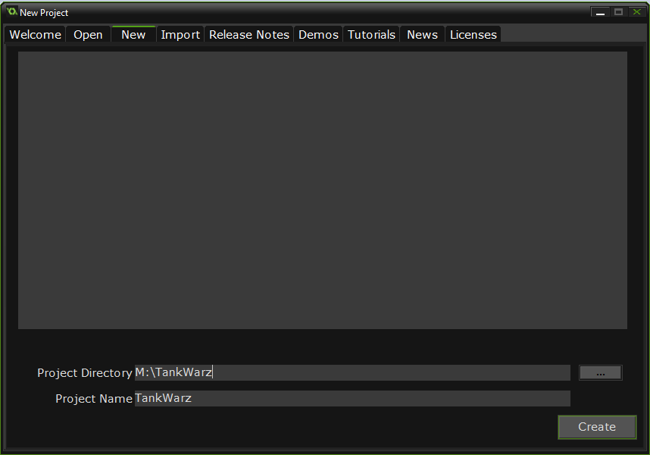

## Step 2. Create the room

A room is the world in which the game will take place. Our room will be called “Arena” and will use a simple colour for the background.

* Right click on “Rooms”
* Select “Create Room”

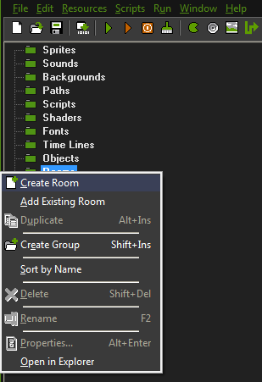

* Select the “Settings” tab
* Name the room “Arena”
* Make it 900 X 900

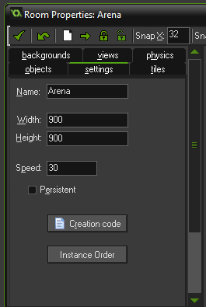

* Select the “backgrounds” tab
* Make sure “Draw background color” is selected
* Click on “Color” and select the colour circled below.

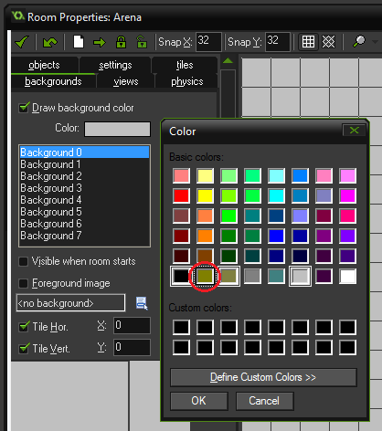

* Select the green check mark to save the room.

## Step3. Add a sprite for the player

A sprite is a graphic or animation that exists in the game world. These are the visuals of things that are in our game.

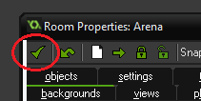

* Right click on “Sprites” and add a sprite.

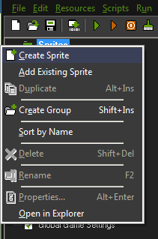

* Name the sprite “sprTank”
* Click “Center” to center the origin
* Select “Precise collision checking”

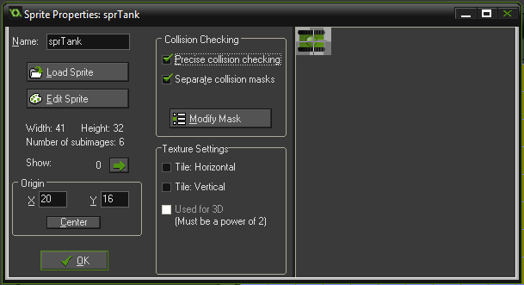

* Select “Load Sprite” and select “tank_0.png” to tank “tank_5.png”
* Select the “Show Preview” checkbox to see the animation

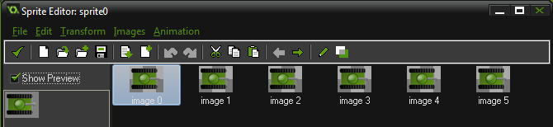

## Step 4. Add an object for the player

Objects are the details about the things in the world. Just as a sprite determines what something in the game looks like, an object defines what it is; its behaviours and attributes.

* Right click on object and select “Create object”
* Name it objTank1
* Make it visible and solid

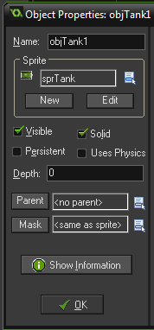

* Locate the “Add Event” button, click it and select “Create”

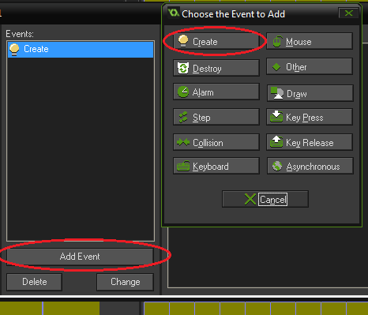

* With the Create event selected (Highlighted) Click the “control” tab
* Under “Variables” Drag the “VAR” icon into the actions window

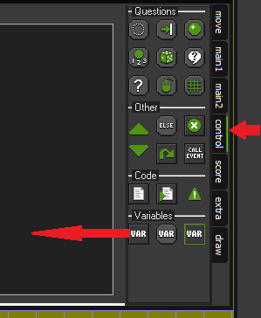

* The “Set Variable” pop-up will appear.
* Name the variable ForwardSpeed
* Give it a value of 4

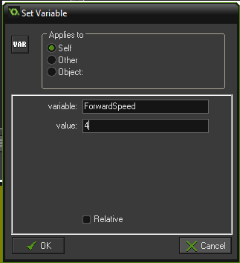

* Repeat the process to add a variable called BackwardSpeed with a value of -2
* Repeat the process to add a variable called RotationSpeed with a value of 5

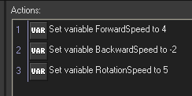

* Add an event for the “W” (Forward) key.
* Click “Add Event” 🡪 “Key Press” 🡪 “Letters” 🡪 “W”

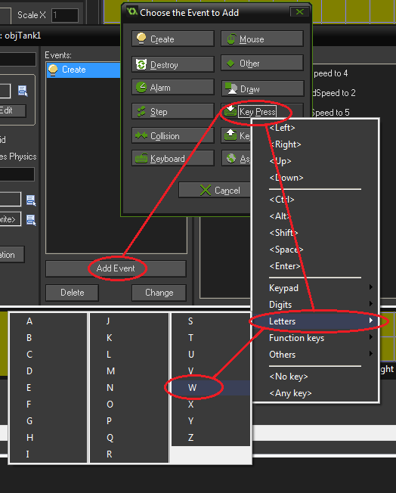

* With the Create event selected (Highlighted) , make sure the control tab is still selected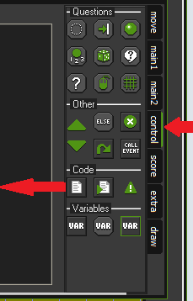
* Drag the code option into the action windows. The actions window will look like this:

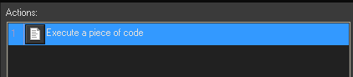

* The code window will appear
* Enter this code:

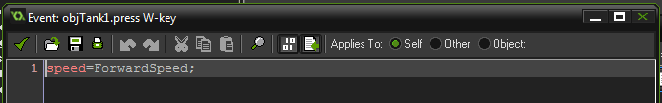

* Add an event for the “W” release (Forward) key.
* Click “Add Event” 🡪 “Key Release” 🡪 “Letters” 🡪 “W”

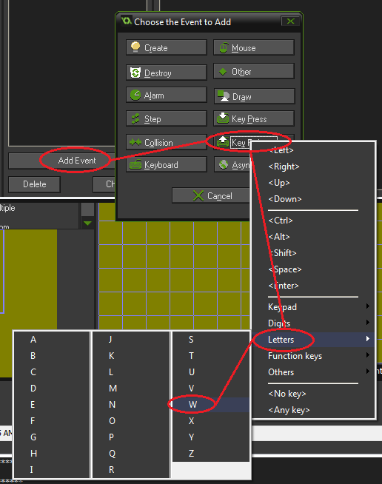

* Drag the code option into the action windows
* Enter this code for the W release:

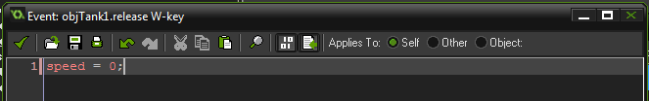

* Repeat for the “S” press and release, but use BackwardSpeed instead of ForwardSpeed
* Add a keyboard event for the “A” key

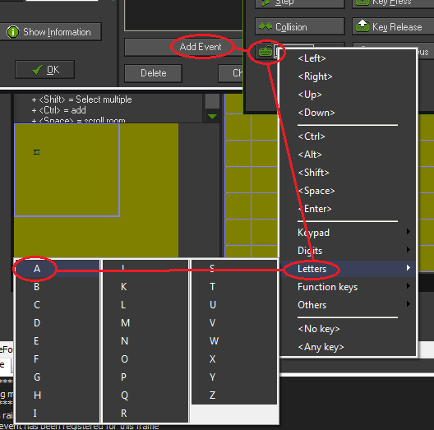

* Add the following code to it:

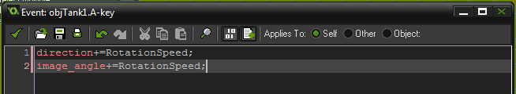

* Add a keyboard event for the “D” key
* The event has the same code as the “A” key only instead of +=, use -= (to reverse the direction of rotation)
* Hit the green checkmark to save your tank.

## Step 5. Adding a tank to the room

* Click on your arena
* Select the objects tab
* Click on the list icon  and select objTank1
* Click on the arena to place a tank

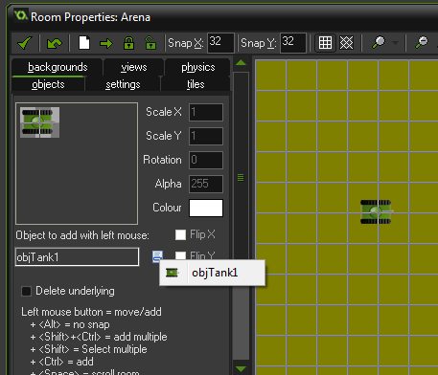

* Click on the  to test your tank

## Step 6. Making a bullet

Make a sprite to represent a bullet.

* Use the bullet.png image
* Name it sprBullet1
* Center the origin
* Use precise collision detection
* Click “OK”

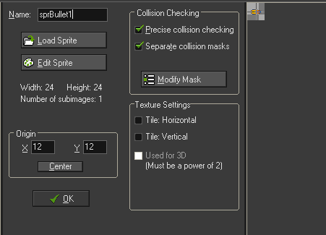

* Make an object to represent the bullet
* Name is objBullet1
* Select the sprite sprBullet
* Make sure it is visible and solid

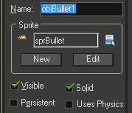

* Declare a variable called range with a value of 30

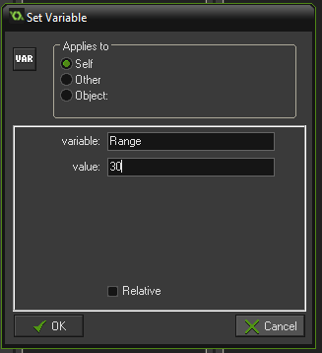

* Add a create event that sets an alarm to fire after Range has expired (about 3 seconds).

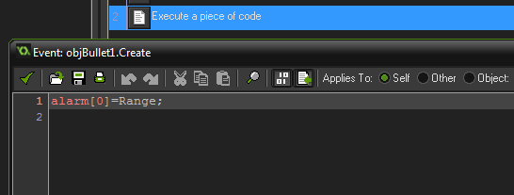

* When the alarm fires, destroy the bullet:

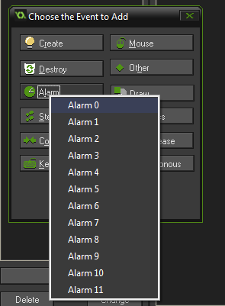

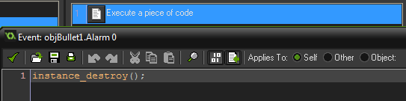

## Step 7. Making the tank shoot

* Select the tank object
* Add a key press event
* Add the following script that:
  + Creates a bullet at the location of the tank
  + Sets it facing in the direction of the tank
  + Rotates the image in the same direction of tank image
  + Set its speed to 10

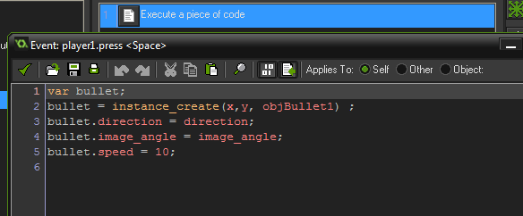

## Step 8. Making something that can be shot

* Create a sprite called sprRedBrick
* Load the redbrick.png graphic
* Center the origin
* Turn on precise collision detection

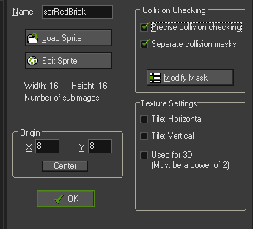

Create an object for the sprite:

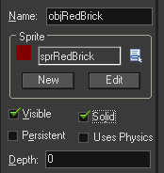

Create a collision event for the block when it is hit by a bullet:

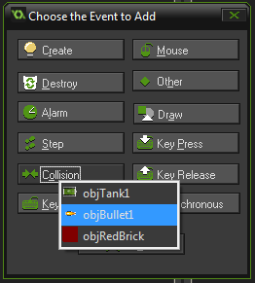 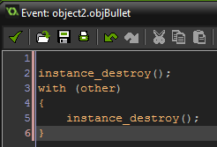

Now we can shoot the red brick and destroy it… …but why would we want to? Let’s make it get in the want so we can’t drive over it. Add the following event to the tank:

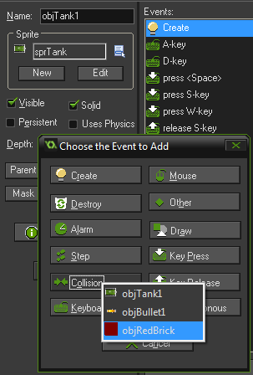

If the tank hits the wall, stop it:

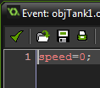

Now switch to the room, select the object tab and draw some red bricks into your world.

## Step 9. Adding a second tank

Right click on the tank object and select duplicate. Call the new object objTank2.

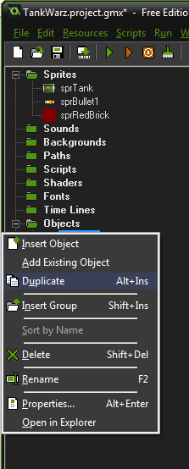

We will need to change the events so it uses different keys to moves around:

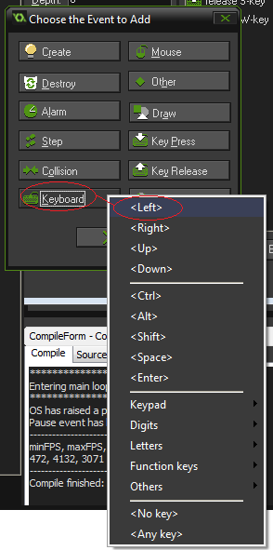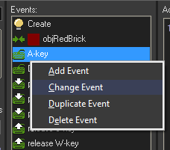

Repeat the process to make:

* W the Up key press
* S the Down key press
* D the Right key press
* Space the Enter key press
* S key release to the Down key release
* W key release to the up key release

Use the objects tab in the room to add a second tank (preferable somewhere far away from the first tank.

Test that both tanks move.

# Step 10. Making the tanks shoot each other

Try this…

1. Duplicate the objBullet 1. Call it objBullet2
2. Change the enter button of objTank2 so it creates an instance of objBullet2:

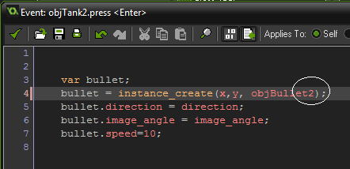

1. Add a collision event to objTank1 so it is destroyed by objBullet2:

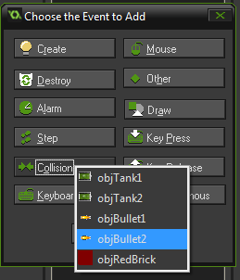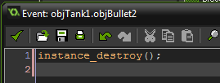

1. Repeat for objTank2 so that it is destroyed by a collision with objBullet2.
2. Add a collision to the objRedBrick with objBullet2 (just copy and paste the code file from objBullet1).
3. Test the game.